|  |  |  |
| --- | --- | --- |
| **1.** | **LAB NUMBER:** | **5** |
| **2.** | **TITLE:** | **Superposition Circuit Analysis** |
| **3.** | **OBJECTIVES:** |  |

After completing this lab, the student will be able to:

a. measure the source and branch currents,

b. verify the Superposition Method of Analysis.

**4. EQUIPMENT:**

DC Power Supply: Uni PS-2303

Digital Multimeter: RIGOL DM 3058E

Experimenter board (C.A.D.E.T.) or a Breadboard

Multisim Software

**5. COMPONENTS:**

1 - 470 Ω ½ watt 5% Resistor

1 - 510 Ω ½ watt 5% Resistor

1 - 620 Ω ½ watt 5% Resistor

1 - 1k Ω ½ watt 5% Resistor

1 - 2k Ω ½ watt 5% Resistor

**6. TEXT REFERENCE:**

Circuit Analysis: Theory and Practice (5th Edition): A.H. Robbins and W.C. Miller

Section 2.6: Measuring Voltage and Current

Section 9.1: Superposition Theorem

**7. PRE-LAB ASSIGNMENT:**

Study Fig. 1 and do the following calculations:

(Attach all your calculations at the end of your report as an Appendix)

Figure 1:

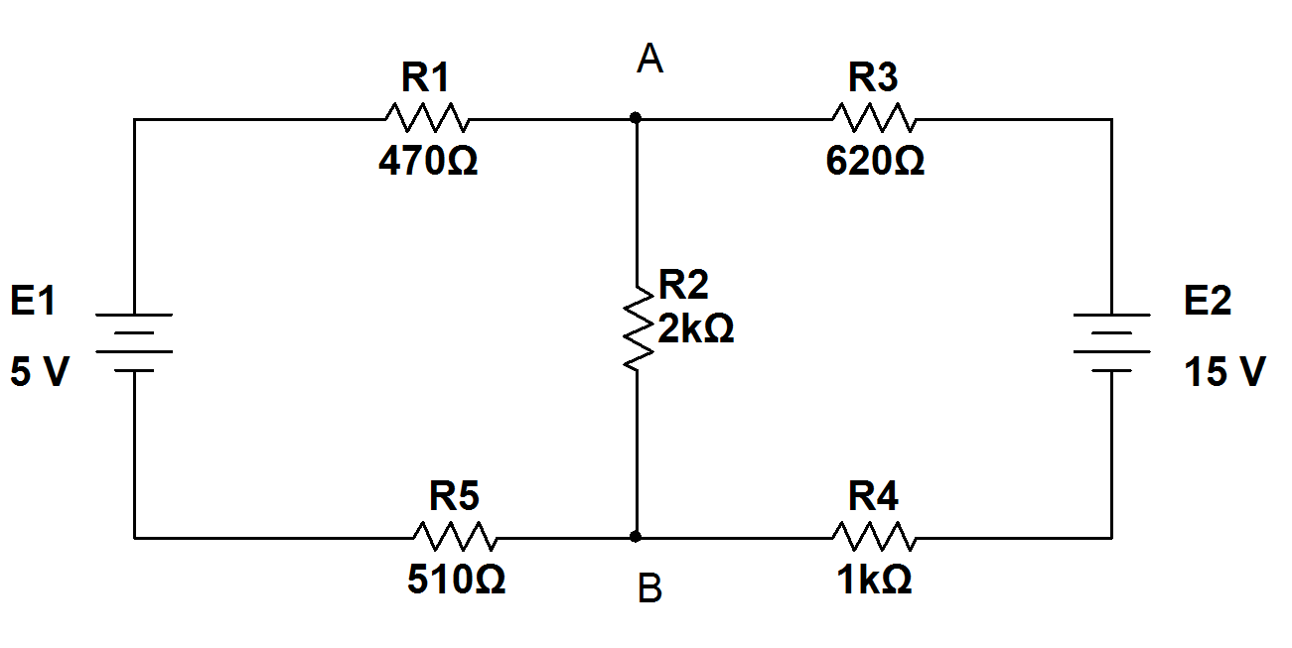

1. Contribution from E1: Redraw the circuit with E2 shorted, calculate the currents through all resistors. *Note the directions of currents on your diagram*. Record your results in Table 1.

Table 1:

|  |
| --- |
| IR11 = 2.666 mA |
| IR12 = 1.193 mA |
| IR13 = 1.472 mA |
| IR14 = 1.472 mA |
| IR15 = 2.666 mA |

Calculations:

R4+R3 = 620+1000 = 1620Ω

R3+4||2 = (­1620*2000)/ (1620+2000) = 895.027Ω

RTH = R1+(3+4||2) +5 =470 + 895.027 + 510 =1875.027Ω

VTH/RTH= I initial current = 5/1875.027=2.666mA

I target = R other / R sum * I source

I R2 circuit 1 = 1620/3620 *2.666*10-3

I R2 circuit 1 = 1.193mA

I R3+4 circuit 1 = 2000/3620 *2.666*10-3

I R3+4 circuit 1 = 1.472mA Note R3 and R4 have the same current.

b) Contribution from E2: Redraw the circuit with E1 shorted, calculate the currents through all resistors. *Note the directions of currents on your diagram*. Record your results in Table 2.

Table 2:

|  |
| --- |
| IR21 = 4.419 mA |
| IR22 = 2.165 mA |
| IR23 = 6.585 mA |
| IR24 = 6.585 mA |
| IR25 = 4.419 mA |

R1+R5 = 470+510 = 980Ω

R1+5||2 = (­980*2000)/ (980+2000) = 657.718Ω

RTH = R3+(1+5||2) +4 = 620 + 657.718 + 1000=2277.718Ω

VTH/RTH= I initial current =15/2277.718 =6.585mA

I target = R other / R sum * I source

I R2 circuit 2 = 980/2980 *6.585*10-3

I R2 circuit 2 = 2.165mA

I R1+R5 circuit 2 = 2000/2980 *6.585*10-3

I R1+R5 circuit 2 =4.419mA Note R1 and R5 have the same current.

1. Total contribution: Add the above two results, pay attention to the current directions in each contribution to decide on addition or subtraction. *Note the final current directions in Fig. 1*. Record your results in Table 3.

Table 3:

|  |  |  |
| --- | --- | --- |
| Circuit 1 | Circuit 2 | Superposition circuit |
| IR11 = 2.666 mA | IR21 = 6.585 mA | IR1 = -1.753 mA |
| IR12 = 1.193 mA | IR22 = 2.165 mA | IR2 = 3.358 mA |
| IR13 = 1.472 mA | IR23 = 6.585mA | IR3 = 5.113 mA |
| IR14 = -1.472 mA | IR24 = 6.585mA | IR4 = 5.113 mA |
| IR15 = 2.666 mA | IR25 = 4.419 mA | IR5 = -1.753 mA |

­­­note: negative signs added for direction.

**8. MEASUREMENTS:**

|  |  |  |  |
| --- | --- | --- | --- |
| Resistor label | Resistor value (Ω) | Resistor measured (Ω) | Resistor range(Ω) |
| R1 | 470 | 466.75 |  |
| R2 | 2000 | 2.027 k |  |
| R3 | 620 | 612.99 |  |
| R4 | 1000 | 985.00 |  |
| R5 | 510 | 503.72 |  |

|  |  |  |
| --- | --- | --- |
| Voltage label | Voltage intended | Voltage measured |
| V1 | 5 | 5.0044 |
| V2 | 15 | 15.009 |

**A – Current due to E1 measurements:**

a) Built the resistor circuit of Figure 1 with the 5V source only. Source 15V is not connected and R3 is connected to R4 to simulate the shorting of this source.

b) Set the DMM to measure current then measure all resistor currents. Record your results in Table 4:

Table 4:

|  |
| --- |
| IR11 =2.683 mA |
| IR12 =1.183 mA |
| IR13 =1.500 mA |
| IR14 =1.500 mA |
| IR15 =2.685 mA |

c) Compare Table 4 to Table 1.

**B – Current due to E2 measurements:**

d) Remove the 5V source and connect R1 to R5. Open the connection between R3 and R4 then connect the 15V source there.

e) Set the DMM to measure current then measure all resistor currents. Record your results in Table 5:

Table 5:

|  |
| --- |
| IR21 =6.645mA |
| IR22 =2.158mA |
| IR23 =4.500mA |
| IR24 =6.669mA |
| IR25 =4.5001mA |

f) Compare Table 5 to Table 2.

**C- Total currents measurements:**

g) Remove the short between R1 and R5. Connect the 5V source to the circuit (Both sources connected now).

h) Measure all resistor currents and record your results in Table 6:

Table 6:

|  |
| --- |
| IR1 =-1.675mA |
| IR2 =3.409mA |
| IR3 =5.084mA |
| IR4 =5.084mA |
| IR5 =-1.675mA |

i) Compare Table 6 and Table 3.

**D – Multisim simulations:**

j) Create a Multisim circuit (similar to Fig. 1) with:

1. Voltmeters to measure source voltages.

2. Ammeters to measure all resistor currents.

Loading effect in the simulation??

**9. LAB REPORT REQUIREMENT:**

Your team’s Lab Report should contain the followings:

**A Cover Page** with Lab Number, Lab Title, Team members’ Names and Date.

**Result Pages** with:

**A – Current due to E1 measurements:**

Results:

Show a copy of Table 4.

Discussions:

1. Answer 8 (c).

2. What causes the differences? Show some proof to your answer.

**B – Current due to E2 measurements:**

Results:

Show a copy of Table 5.

Discussions:

1. Answer 8 (f).

2. What causes the differences? Show some proof to your answer.

**C- Total currents measurements:**

Results:

Show a copy of Table 6.

Discussions:

1. Answer 8 (i), taking Multisim currents into consideration.

2. What causes the differences? Show some proof to your answer.

**D – Conclusion:** (*it helps to compare your prelab with measured results*)

1. Has the Lab proved the validity of the Superposition theorem? Explain your answer.
2. Are all the Lab objectives met? Explain if some are not.

**Appendix**:Attach a printout of **Multisim** simulation and all **Pre-Lab calculations**.